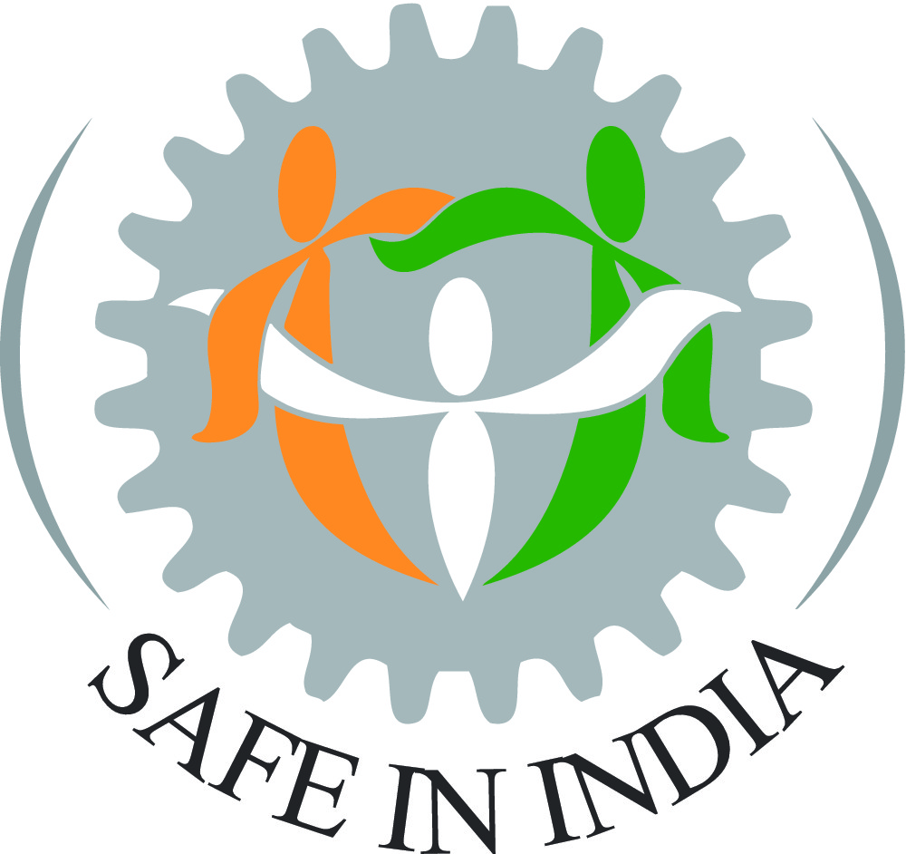
CIN: U74999HR2017NPL070537

Role Name: Communication/Social Media Executive, Safe in India Foundation (SII)
Role description: SII is looking to recruit a part time/full time executive, with passion for social causes, to run its social media platforms. Key deliverables include the following:

- Help deliver the manager SII’s strategic roadmap for communications through disciplined and high quality activities on SII’s social media platforms in Hindi and English within agreed deadlines (for both physical and virtual channels) for all its key stakeholder groups, including workers, the government and its agencies, the automotive sector, and other strategic partners.
The roadmap will aim to empower our key stakeholder - workers with knowledge of ESIC (target audience: 5 crore+) and Occupational Safety and Health (OSH) for Hindi worker audience, mainly in automotive sector (target size: 1 crore+), informed by and building on SII’s recent work on its online channels and its on-the-ground experience with workers.
It will also aim to inform other stakeholders of the issues of worker safety and ESIC, and influence implementation of corrective solutions.
- Create audio/video/canva/etc content on worker safety and ESIC healthcare and compensation services (eg. effective video/multimedia content), to empower 100,000+ workers in 2 years – both online and in physical meeting formats. Deliver impact on agreed communication approaches through measured improvement in engagement and quality of engagement, with evidence of increasing knowledge of these subjects among target audience.
- Post the above Hindi and English content various SII platforms, track and analyse the data of these platforms, create ongoing learnings and improvements for improving impact on the target audience among workers, auto sector executives, government officials/agencies, the media, the public, and other influencers by developing and disseminating the right content through online and offline communication approaches eg. Twitter, English Facebook page, LinkedIn, FB etc. Demonstrate impact through increase in quality followers, engagement, and evidence of actions taken by these groups.
- Support in any online/offline event management aspect of flagship programs that SII might organize from time to time, such as the release of its annual reports, worker events etc. to maximize the observable impact of these events.
Skills and experience needed in/for:
- Implementation of strategy/roadmap under the direction of/support from SII CEO and Advisors
- About 2 or more years of relevant experience
- Proficiency in Hindi (excellent), English (Good-very good)
- Demonstrated experience in creating communications content, both for physical and virtual channels. Specific experience in YouTube, Facebook, Twitter, LinkedIn, Zoom, and/or Wix preferred.
- Experience in online and offline event management preferred
- Managing others (staff, external vendors etc.) to deliver content and social media activities
- Understanding and articulating social security/workplace safety rights and responsibilities for workers in Hindi
- Understanding and articulating in English

The role requires a self-driven individual who works well in small teams and who aligns with SII’s values; central focus on worker well-being is essential.
​
Remuneration: Competitive and negotiable based on skills and seniority. Please feel free to state your expectations. For the right candidate, SII would make an attractive offer. Please do not expect a commercial sector compensation.
​
Location: Ideally Gurgaon/South Delhi.
​
Safe in India Foundation Background: SII is a community service organisation that was founded by a group of alumni of IIMA in 2016 in response to shocking evidence on grievous crush injuries to workers in the factories of the automobile component manufacturers. SII has since evolved in its mission through four social-impact areas: (1) assisting injured workers in accessing ESIC’s healthcare and accident compensation, (2) using this evidence to improve safety in the Indian auto sector benefitting over one crore workers, (3) drawing from its on-the-ground, enable improvements in ESIC processes, potentially benefiting over 14 crore Indians who are dependent (directly or indirectly) on ESIC, and (4) empowering workers through knowledge of ESIC and occupational safety.

Since 2016, SII has assisted over 5,000 injured workers with ESIC healthcare and compensation valued more than Rs 30 crores. To learn more about SII’s activities, please read this blog and see this brief video. SII is advised by a prominent Council of Advisors.

Applications/questions: Please send your CV; a (mandatory) covering letter setting out reasons for your interest, your strengths for the role and any expectations; a communications product you created in Hindi and English; and/or ask any clarifications should you wish, in confidence, to Co-Founder & CEO, Sandeep.sachdeva@safeinindia.org by 5th February 2023.

